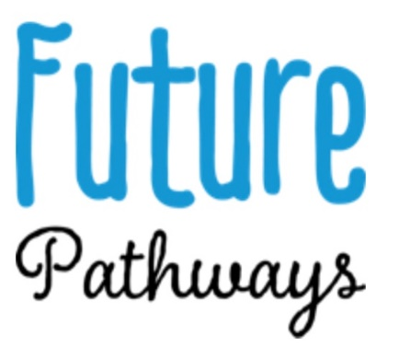
23rd March 2020
Dear Parent/Carer
RE: Covid-19 – Government Guidance for Alternative Provision
Following the closures of schools on Friday we can confirm that we are to remain open until advised otherwise by Government Guidelines or the Local Authority.

The current guidance from the Government stipulates:
“Children in alternative provision (AP) settings
We have defined vulnerable children as those who have a social worker and those with EHC plans. Alternative provision settings serve a small number of children and young people, a high proportion of whom meet this definition of vulnerability.
AP providers are already well-placed to cater for the needs of the children we are defining as vulnerable in a way that would be difficult to replicate elsewhere. The AP sector therefore has a key role to play in helping safeguard this group of children at this difficult time.
The government is asking headteachers of AP providers to work with government – through regional schools commissioners, local authorities and other key agencies on the best way to protect these vulnerable children, including by keeping AP settings open where it is feasible to do so.”
[https://www.gov.uk/government/publications/coronavirus-covid-19-guidance-on-vulnerable-children-and-young-people/coronavirus-covid-19-guidance-on-vulnerable-children-and-young-people]

To this end, Future Pathways will remain open in order to protect and safeguard vulnerable young people, we will continue to carry out stringent hygiene practices at all times.

Please get in touch if you have any queries.

Yours Truly,
Lauren Hogg
Project Manager
Future Pathways CIC
lauren@futurepathwayscic.com
07715 925357

